Jenkins – Continuous Integration Demo using C# Class Library and MSTest Project

Step 1: Create new Library project

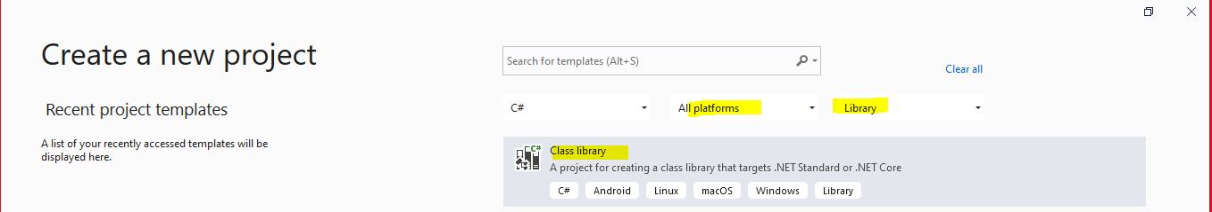

Step 2: Give project name and solution name

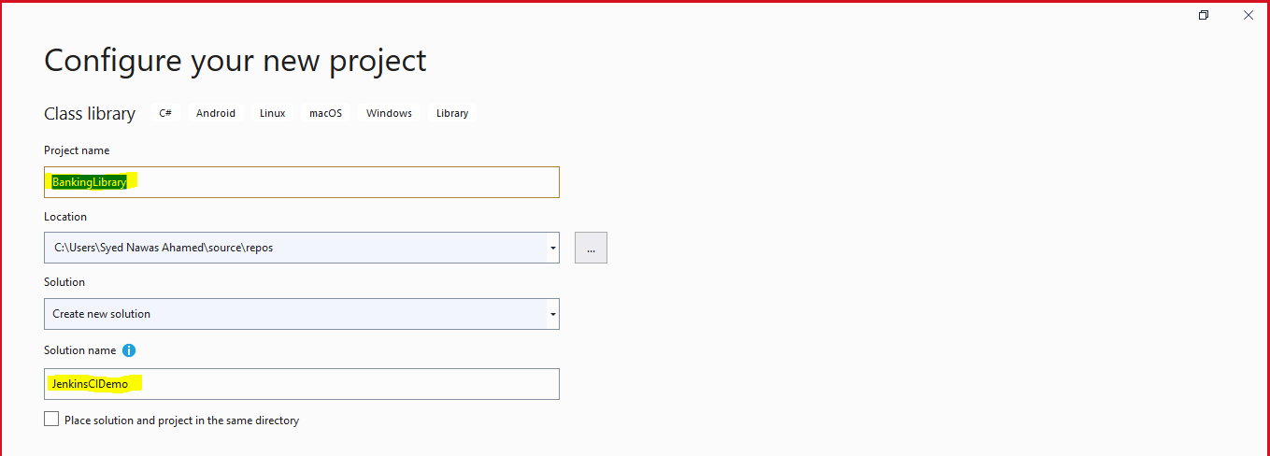

Step 3: Implement as follows

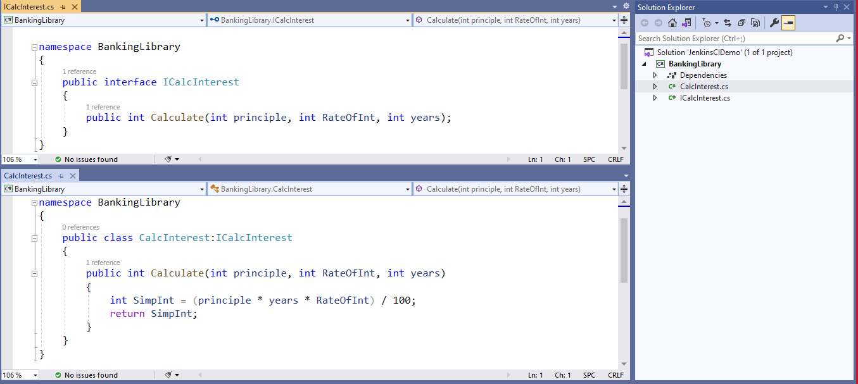

Step 4: Add a unit test project (.Net Core)

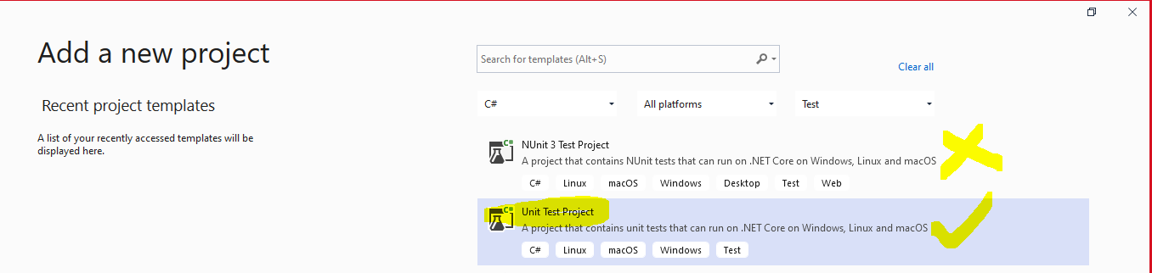

Step 5: Implement as follows

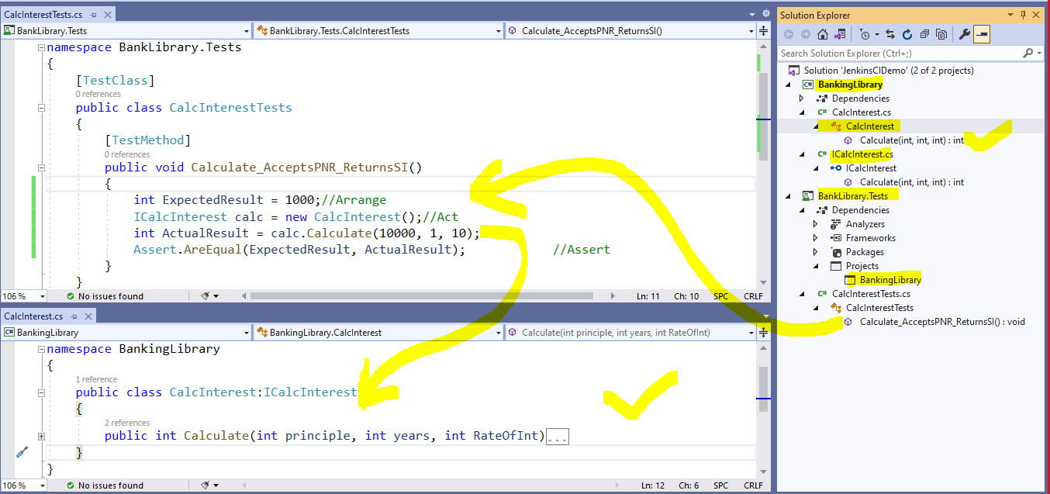

Step 6: Run the test explorer

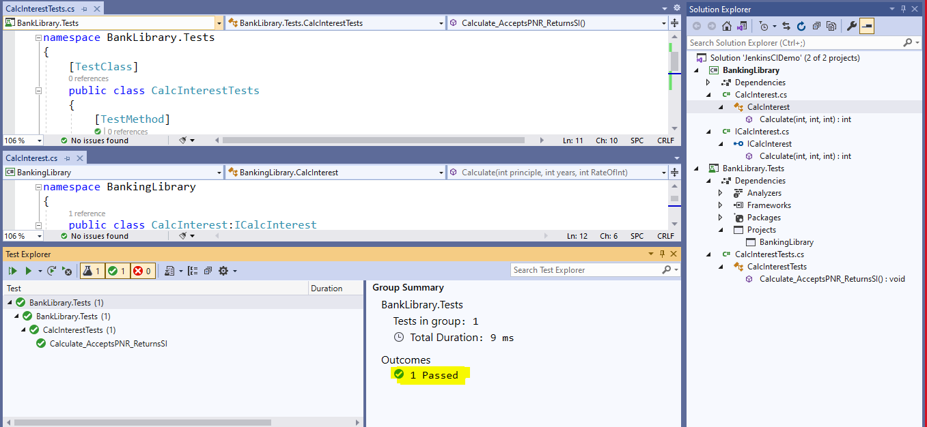

After Build confirm the build in file explorer

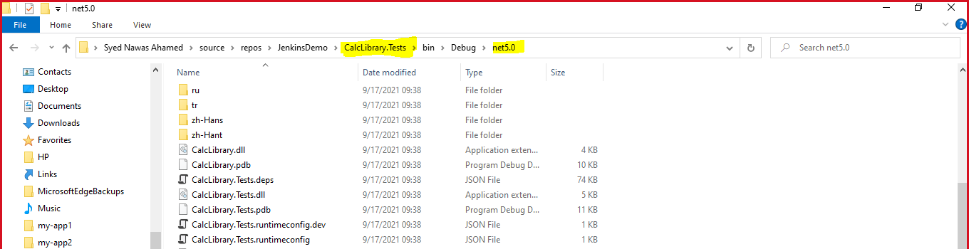

Step 7: Create New GitHub Repository

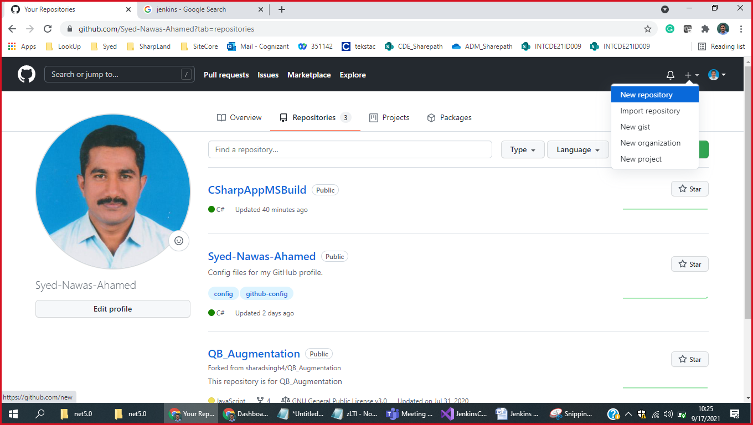

Give Name, Description and Repository type

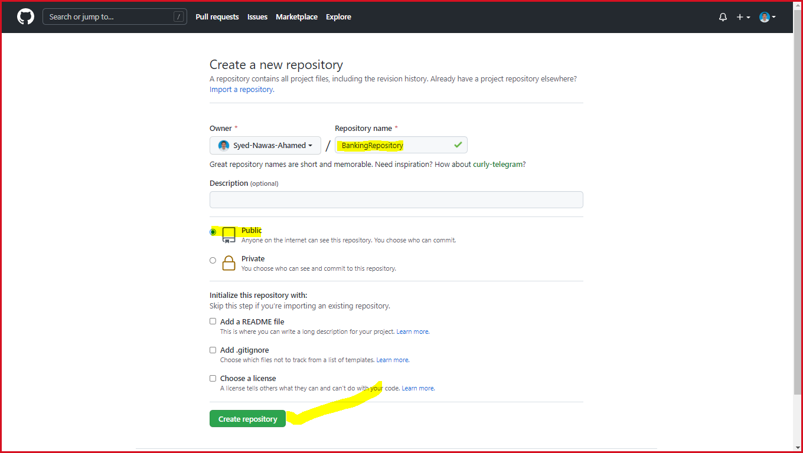

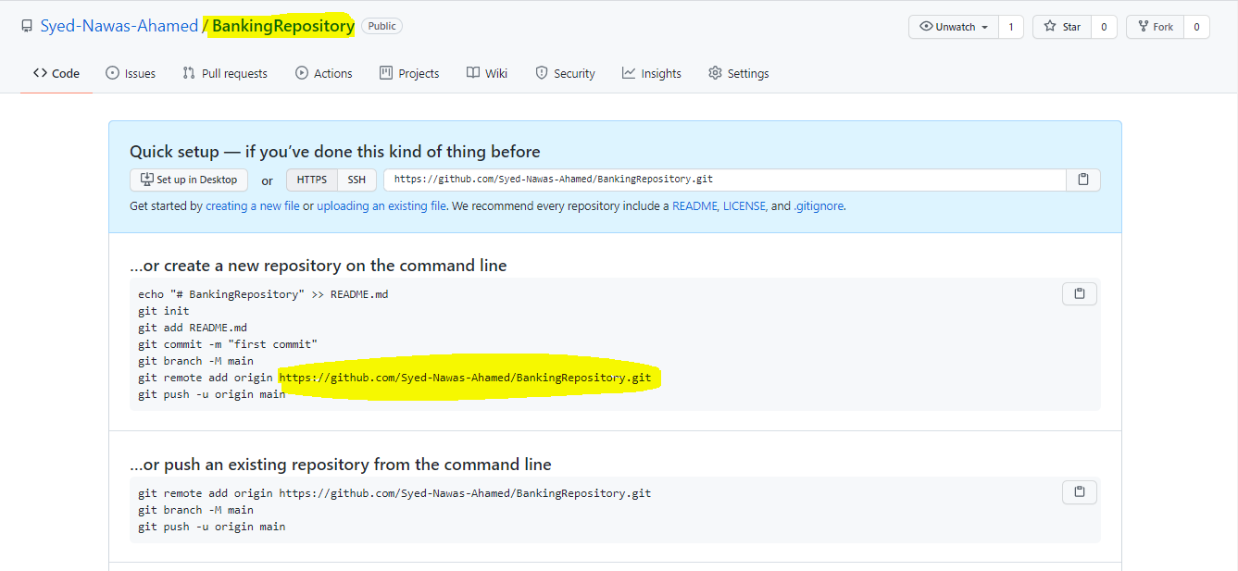

Step 8: Open GitBash CLI on your local project directory as follows,

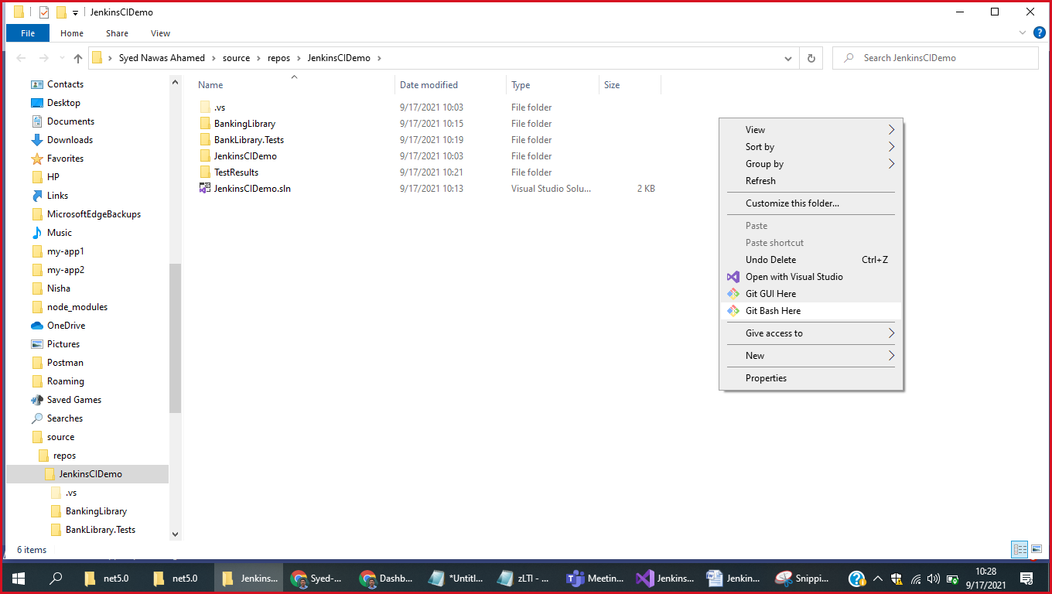

Step 9: Run following commands one by one

* **git init**,
* **git add --all**,
* **git commit – m “Initial Commit version”**
* **git remote add origin** <https://github.com/Syed-Nawas-Ahamed/BankingRepository.git>

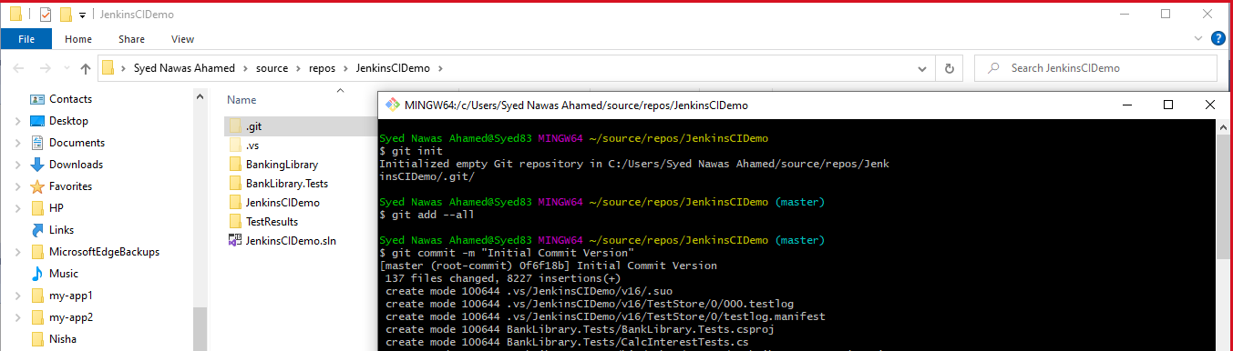

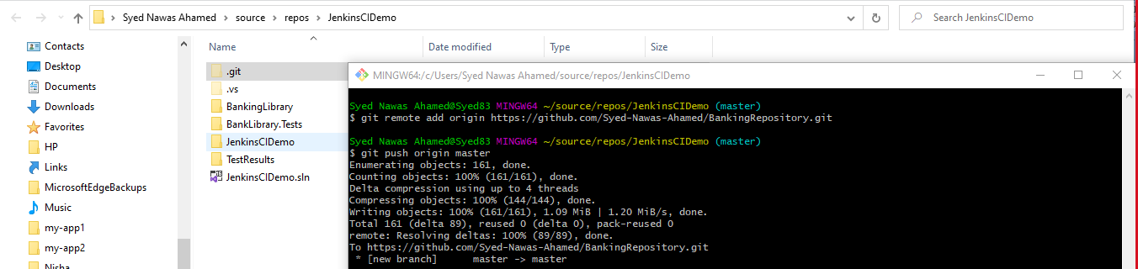

Step 10: Veryify your code pushed in to GitHub Repository successfully as below

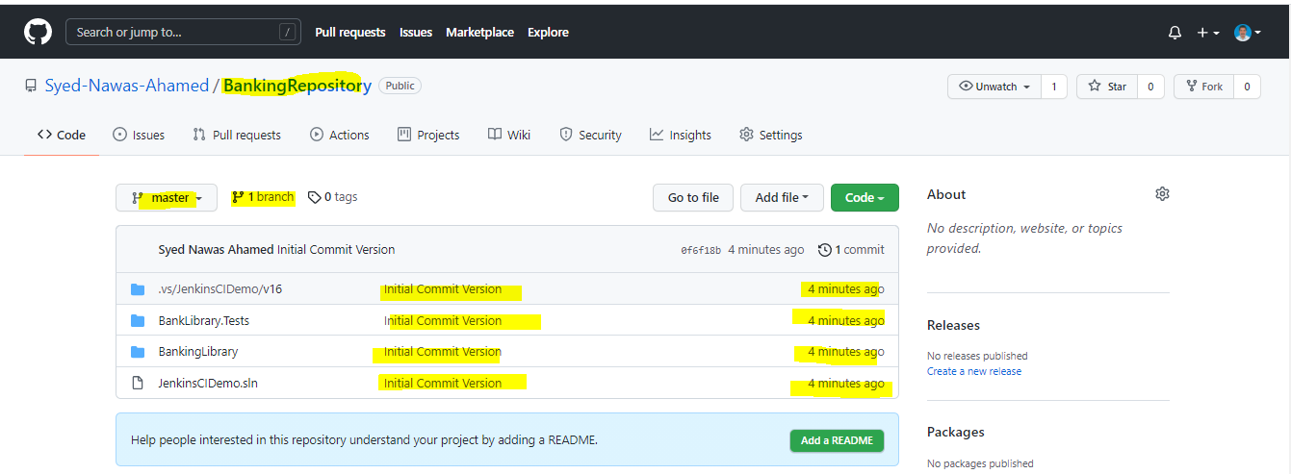

Step 11: Login in to Jenkins and click a “Create a Job” option

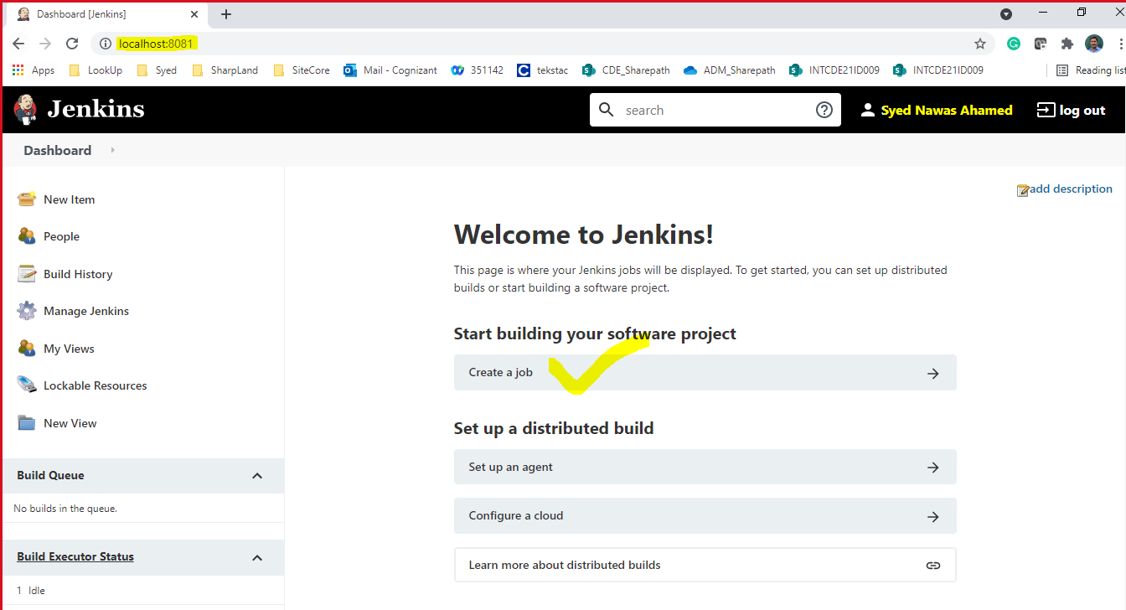

Give **Job Name** and **Job type**

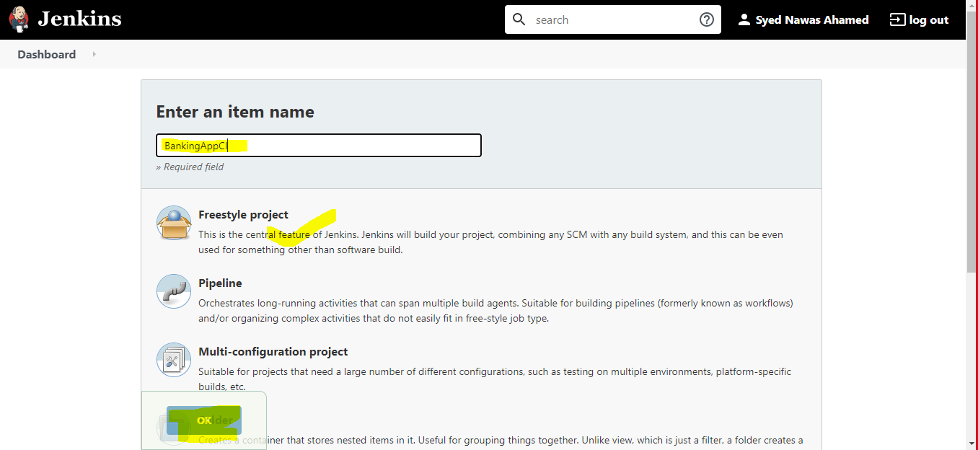

We will be redirected to following Job Configuration page

Do the highlighted changes over there

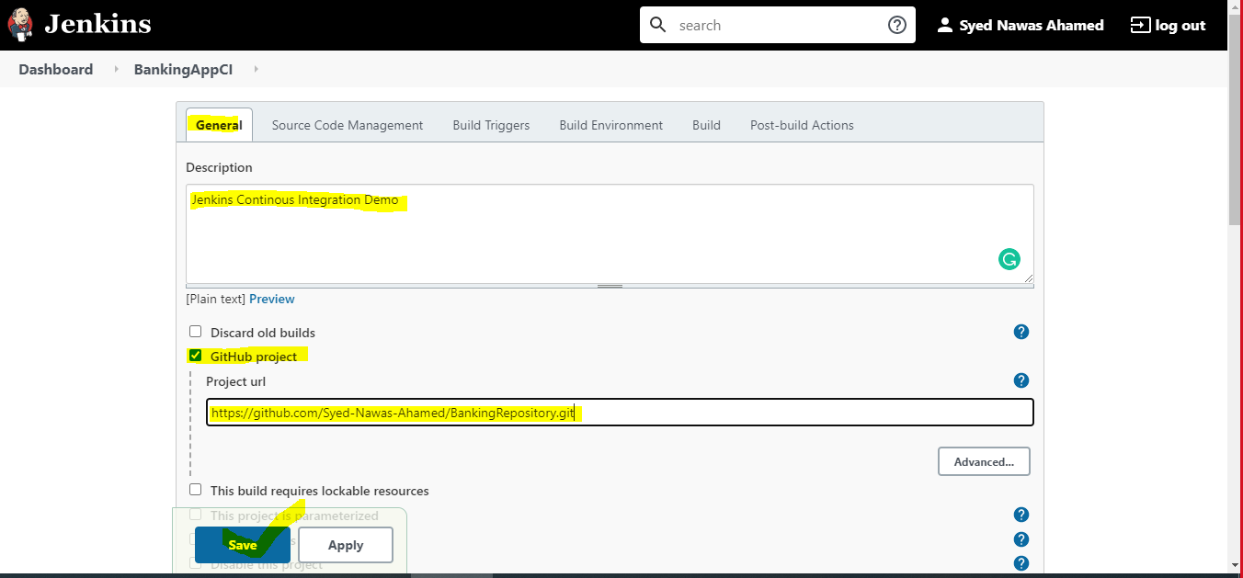

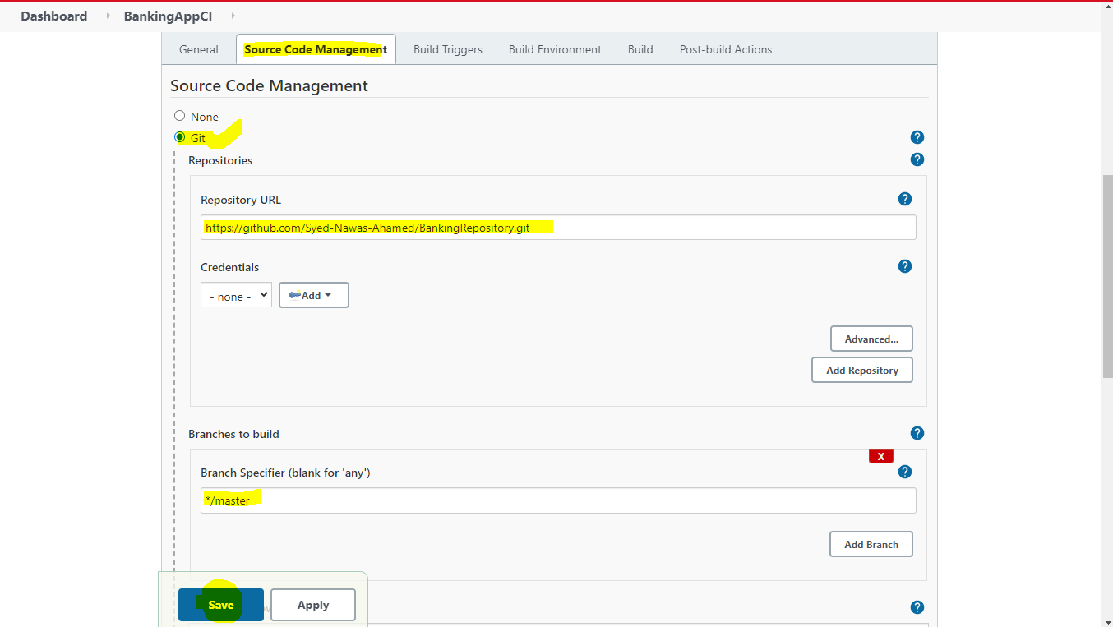

Confirm the job create successfully as below,

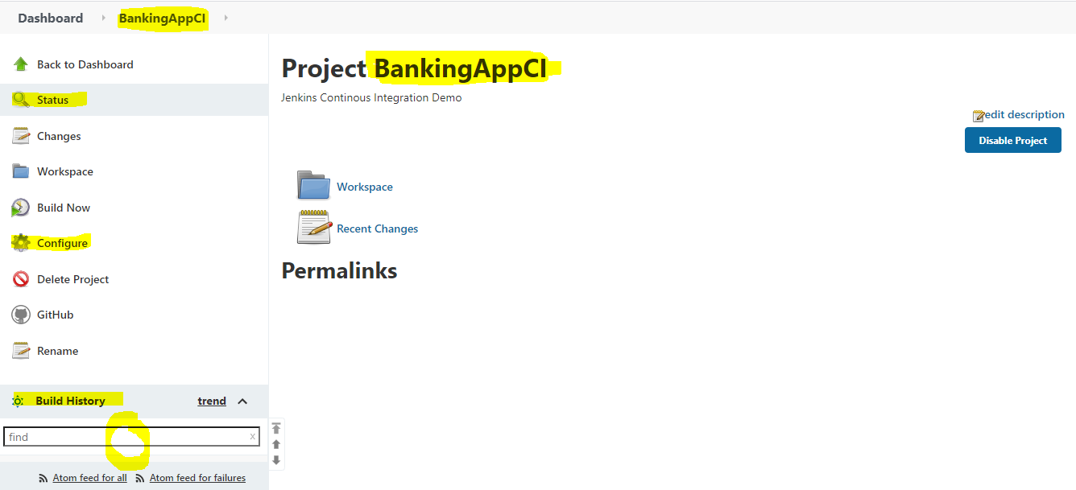

Step 12: Run “Build Now” command as below

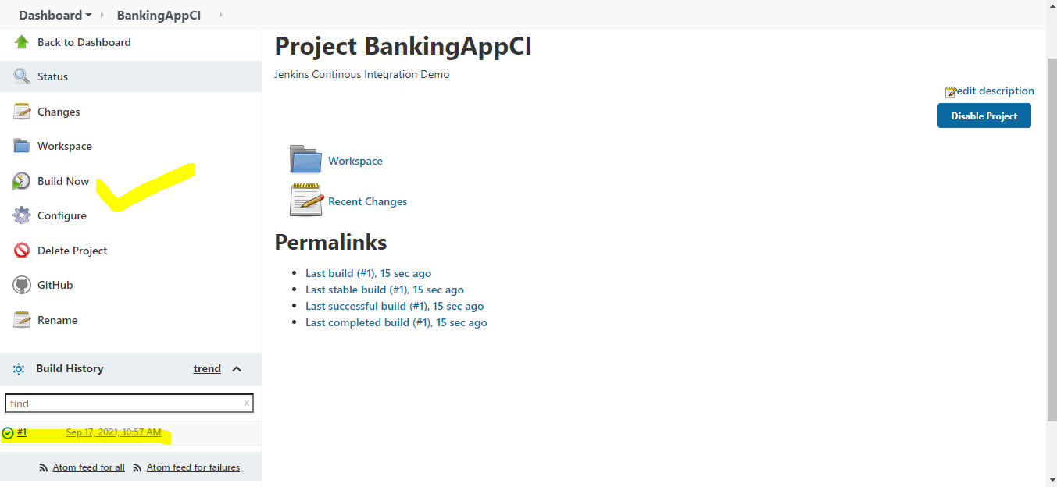

Click the build number to see output

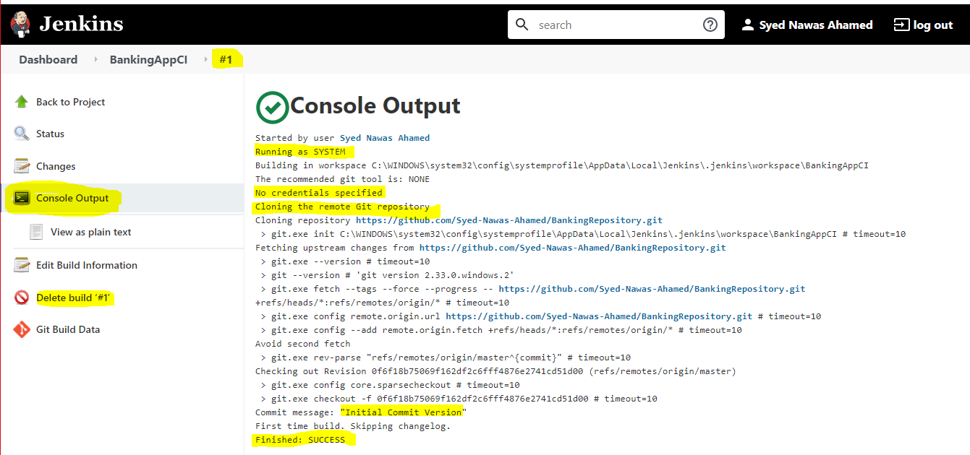

You can repeat the following operations multiple times

* Doing modification / additions with local project
* Push the code in to GitHub
* Run the build in Jenkins

Every time new build will be created in Jenkins.

Additional Research

How to host angular or php applications in to free servers?

7 Possibilities are there <https://www.doodleish.com/2020/06/hosting-for-angular-app-react-app.html>

One of the possibilities is **Github** Pages

How to Host Angular App in Github Pages : <https://www.youtube.com/watch?v=8Mle8owZ3_4>

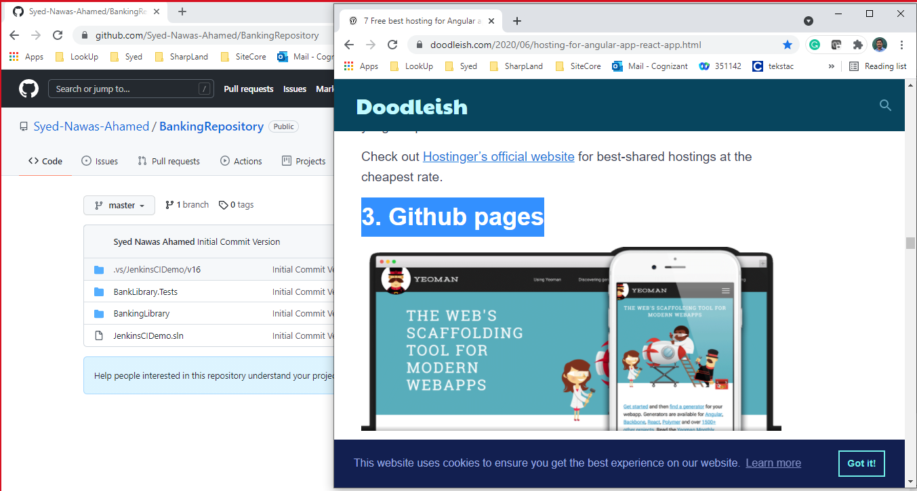

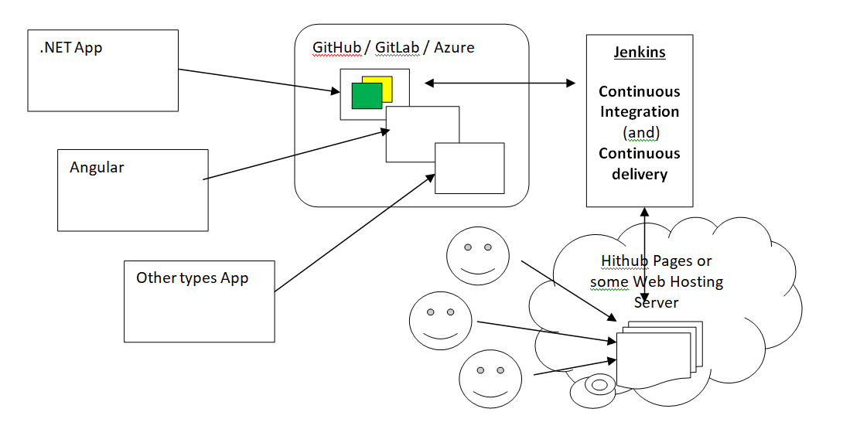

**How to make your Jenkins**

* To do **CI** on GitHub
* To do **CD** on GitHubPages

<https://www.youtube.com/watch?v=cbUqgS82d48>